# Instructions

The Web development team has requested that you create a directory structure and some placeholder files for their new Web site application on the AlmaLinux server you deployed for them previously. Please create the following directories:

**/development**

**/development/website**

**/development/website/images**

**/development/website/js**

Also, please create a file called **index.html** within the Website directory and enter the following text:

**<h1>This site is currently under construction</h1>**

**<img src=”./images/underconstruction.jpg”>**

Finally, search the Internet for a jpeg (image) depicting “under construction.” Download the file to the server. Move this file to the “images” directory and rename it to **underconstruction.jpg**.

Test the file by entering the command:

**firefox /development/website/index.html**

# Screenshots

Paste the required screen shots under each description.

1. Show a directory listing of the **/development** and **/development/website** directoriesA screenshot of a computer

   Description automatically generated
2. Open the **index.html** file with ‘vi’ and show the text required

1. Take a screen shot showing the **index.html** file in Firefox from your test

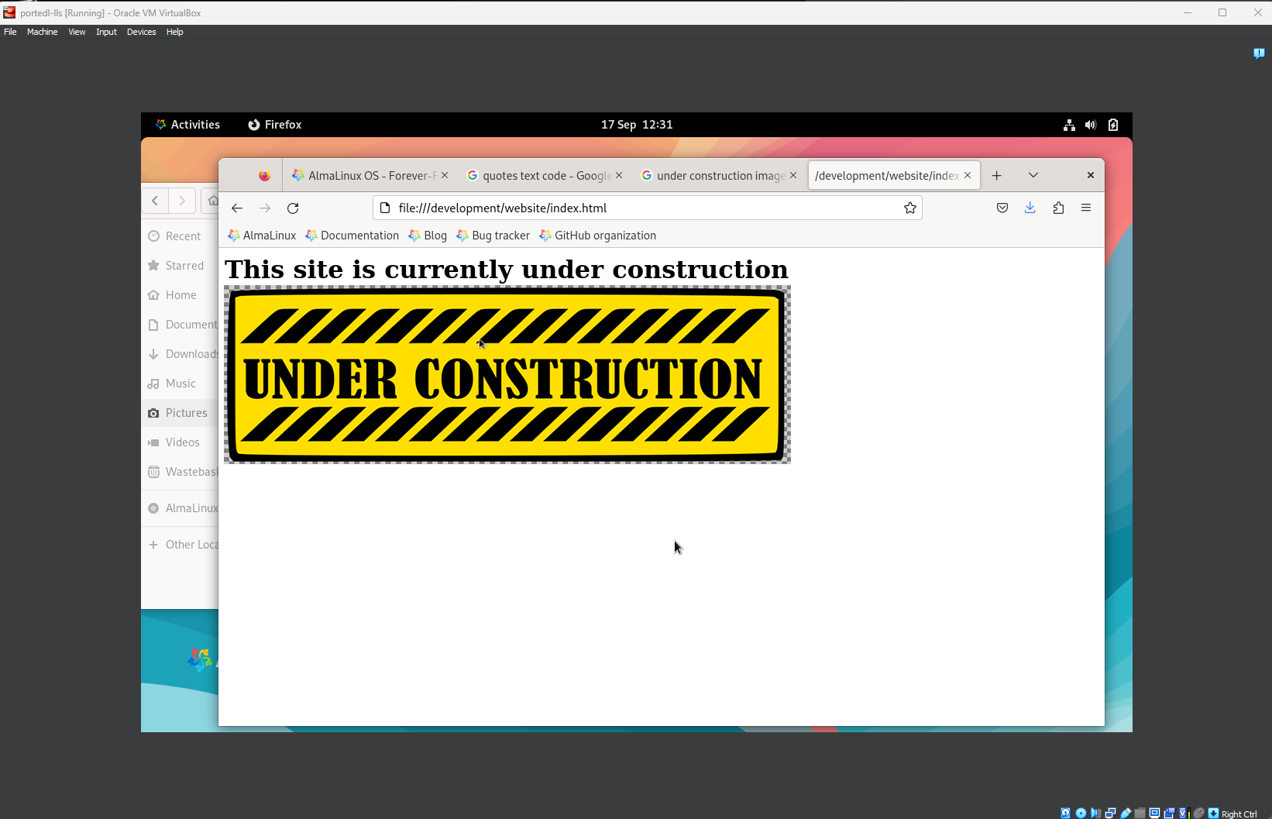

# Documentation

Record and explain all the steps you took to complete the task. Include any commands used, screen shots showing GUI interfaces, or any other information that would help you recreate the task.

**Note: You will be allowed to use this documentation to help you complete future assignments.**

1. Opened a terminal on the AlmaLinux server.
2. Ran the following command to create the required directories:
3. sudo mkdir -p /development/website/images /development/website/js
   * This command creates the /development, /development/website, /development/website/images, and /development/website/js directories in one step using the -p flag to ensure parent directories are created if they don’t exist.
4. Verified the directory structure by listing the directories with:
5. ls -R /development

**Step 2: Creating the index.html File**

1. Navigated to the /development/website directory:
2. cd /development/website
3. Created and opened the index.html file using the vi text editor:
4. sudo vi index.html
5. Entered the following text into the index.html file:
6. <h1>This site is currently under construction</h1>
7. <img src="./images/underconstruction.jpg">
8. Saved the file and exited vi by pressing **Esc**, typing :wq, and pressing **Enter**.

**Step 3: Downloading the "Under Construction" Image**

1. Located an "Under Construction" image from the web and used wget to download it directly into the images directory:
2. sudo wget -P /development/website/images https://cdn.pixabay.com/photo/2017/10/26/17/51/under-construction-2891888_1280.jpg
3. Renamed the image to underconstruction.jpg to match the reference in the index.html file:
4. sudo mv /development/website/images/under-construction-2891888_1280.jpg /development/website/images/underconstruction.jpg
5. Verified the file’s presence by listing the images directory:
6. ls /development/website/images

**Step 4: Setting Permissions**

1. I set the correct ownership for the /development/website directory and its subdirectories so that my user account had full access:
2. sudo chown -R portedl-lls:portedl-lls /development/website
3. Verified that the image file had the correct permissions:
4. sudo chmod 644 /development/website/images/underconstruction.jpg

**Step 5: Testing the Webpage**

1. I tested the index.html file by opening it in Firefox:
2. firefox /development/website/index.html
3. I verified that the page displayed the heading “This site is currently under construction” and the "Under Construction" image.

**Conclusion**

I completed all steps successfully, including the creation of directories, adding the index.html file with the correct content, downloading the image, and verifying the webpage in Firefox.

**Commands:**

**Creating directories**:

1. sudo mkdir -p /development/website/images /development/website/js
2. sudo vi /development/website/index.html
3. sudo mv /development/website/images/under-construction-2891888_1280.jpg /development/website/images/underconstruction.jpg
4. sudo mv /development/website/images/under-construction-2891888_1280.jpg /development/website/images/underconstruction.jpg
5. sudo chown -R portedl-lls:portedl-lls /development/website
6. firefox /development/website/index.html